**LED Flasher**

**Circuit Diagram:**

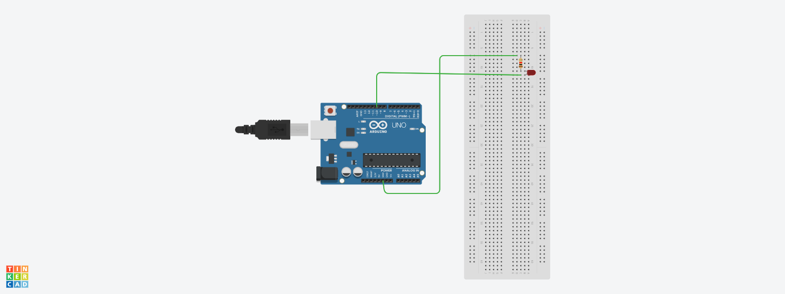

**Hardware Required**

* Arduino Board
* LED
* Connecting Wires
* Resistor

**Theory**

Concept Used:

In this project with the help of arduino board we will blink the led

by delaying it’s on off time.

Learning & Observation:

We came to know how to use arduino board and how to glow an

LED.

**Problem & Troubleshooting**

Using arduino software for the first time was a difficult but it was resolve after referring some example.

**Precautions**

* Connection should be tight .
* Connection should be made properly.

**Learning Outcomes**

From this project we learned how to glow LED in different pattern and it can be use some small toys or sensor based project etc.